Project Design Phase

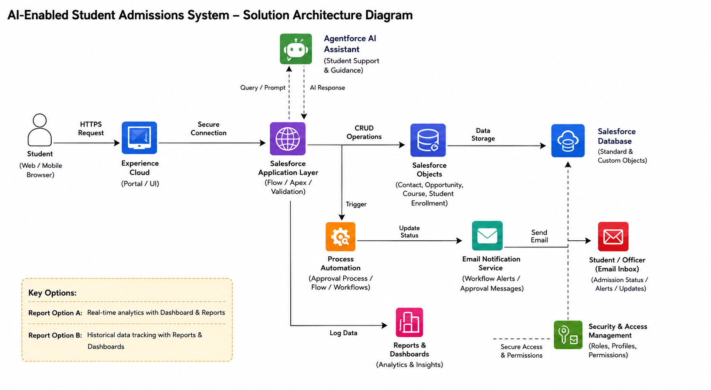

Proposed Solution Template
S.No. | Parameter | Description
1 | Problem Statement (Problem to be Solved) | Educational institutions often rely on manual or partially digital admission processes, resulting in delays, repetitive administrative work, limited application tracking, and difficulty in managing a large number of student inquiries efficiently.
2 | Idea / Solution Description | Develop an AI-Enabled Student Admissions System using the Salesforce Platform to streamline the admission process. The system enables online student registration, application submission, document management, real-time application tracking, AI-powered query resolution using Salesforce Agentforce AI, and workflow automation for admission officers.
3 | Novelty / Uniqueness | The solution integrates Salesforce CRM, Agentforce AI, and workflow automation into a single platform. It offers AI-powered student assistance, automated admission workflows, centralized data management, and real-time application tracking, enhancing both efficiency and user experience.
4 | Social Impact / Customer Satisfaction | The system improves transparency and accessibility by allowing students to apply online, track application status, and receive instant AI-based support. It also reduces administrative workload, improves operational efficiency, and enhances the overall admission experience for educational institutions.
5 | Business Model (Revenue Model) | The application can be offered as a Software-as-a-Service (SaaS) solution for schools, colleges, and universities through subscription-based licensing. Additional revenue can be generated through premium features, AI-powered analytics, custom integrations, training, and maintenance services.
6 | Scalability of the Solution | Built on the Salesforce Cloud Platform, the system is highly scalable and can support multiple institutions, departments, and thousands of student applications. Its cloud-based architecture ensures high availability, secure data management, and seamless performance as the number of users grows.

